Name:  Teacher: | ____________________________________  ________________ |  | Date:_________
 | Year 9 Mathematics  SCORE:  / 37  Mini test 4  Topic – Data analysis and Displays  Full working out MUST be shown to get full marks for each question.
Total Time: | 40 minutes
Weighting: | 5 %
Equipment: | To be provided by the student: Pens and Pencils, scientific calculator, A4 page of notes.

- Callum measures the minutes it takes it him to get to school in the morning. He records the data in the table below [ 7 Marks]
M | T | W | T | F | M | T | W | T | F
15 | 24 | 27 | 12 | 18 | 18 | 15 | 23 | 24 | 19

- From the data above, on which days do you think Callum walked to school? [1]

- What was Callum’s average time to get to school? [2]

- What was the Median time it took Callum to get to school? [2]

- Comparing the average time, to the median time, which do you believe is a more accurate representation of his usual travel time to school? why? [2]

- Georgia received the following scores for her last 4 tests – 56%, 69%, 82%, 89%. She wants to maintain an average of 75% percent. what score would she need on her final test to achieve this average? [3 Marks]

3) The shapes of the graphs below can be described using the words “Positive Skew”, “Negative Skew”, “Symmetrical” and “Bimodal”. Underneath each graph, write the most appropriate term. [6 marks]

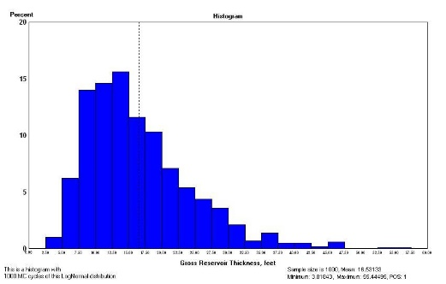
- B)
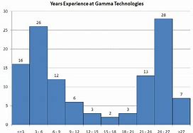

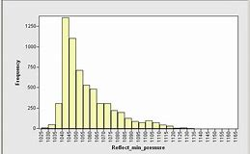
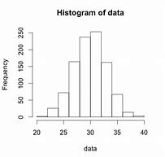
C) D)

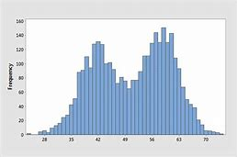
E) F)
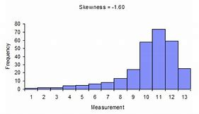

- Sam and Anna read in book “there are 3 times more white cars than black”. They test this claim by surveying their school car parks and see that there is only twice as many white cars than black cars. They come to the conclusion that the books information is wrong. [5 marks]

  - Was the books information first or second hand? [1]

  - List two reasons as to why Sam and Anna may have gotten different results to the book? [2]

  - With relation to population size, do you think that Sam and Anna may have conducted a fair survey to base their belief’s on, or should they reconsider that the book may be correct? [2]

5) The data below is information about the number of hours worked by different employees during 1 week at Built Fast Enterprises. [5 + 4 + 5 + 2 = 16 marks]

Week 1 data. 6, 7, 9, 13, 17, 19, 19, 24, 29, 29, 33, 35, 37, 38, 40, 42, 46, 60, 62
- create a frequency table for this data.

- Use the frequency table to create a histogram.


- The company decided to compare the week 1 data from above, to the week after. Create a back to back stem and leaf plot using the data provided.
Week 2 data. 9, 15, 16, 16, 17, 19, 23, 24, 29, 29, 29, 34, 35, 35, 39, 41, 41, 51, 55

- Which week were the employees the most productive? Use evidence from your stem and leaf plot in your explanation.

